OPERATING Systems

**Name: Girish S Roll No.: AM.EN.U4AIE22044**

--------------------------------------------------------------------------

1. **  
   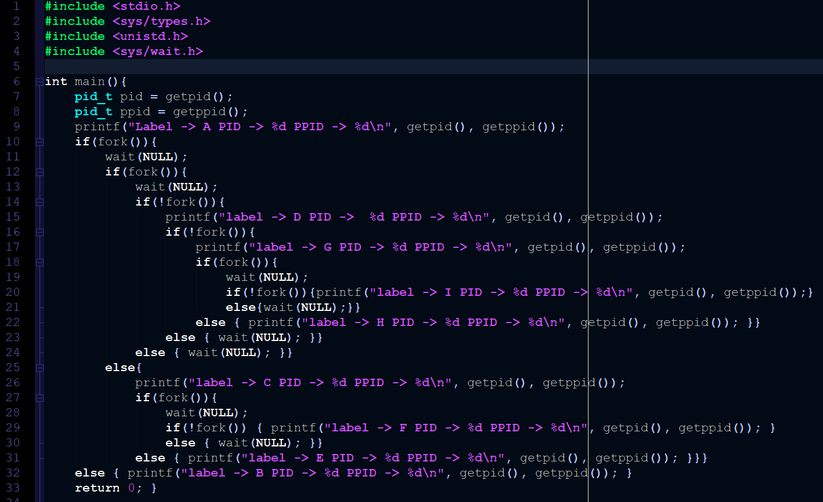  
     
   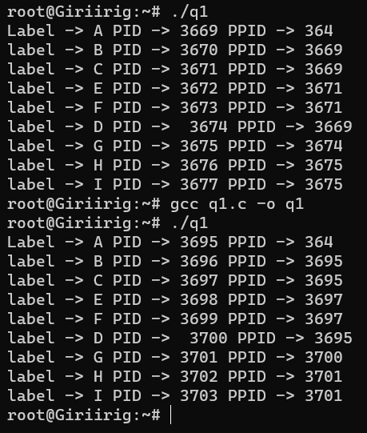 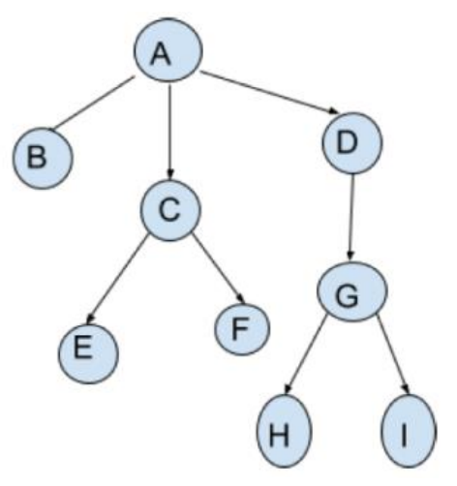**

Yes, the order is same in every execution  
A->B->C->E->F->D->G->G->H->I  
And it follows the process tree, only the Process ID gets reassigned every time

1. **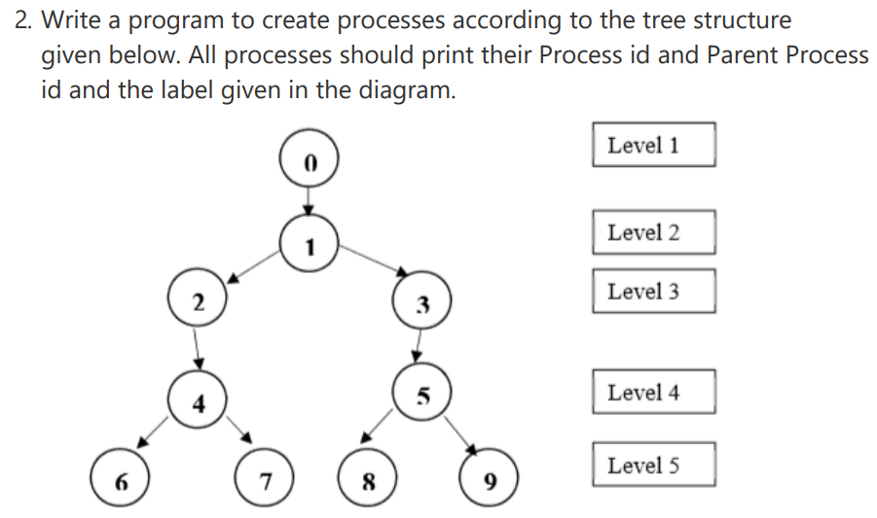  
     
   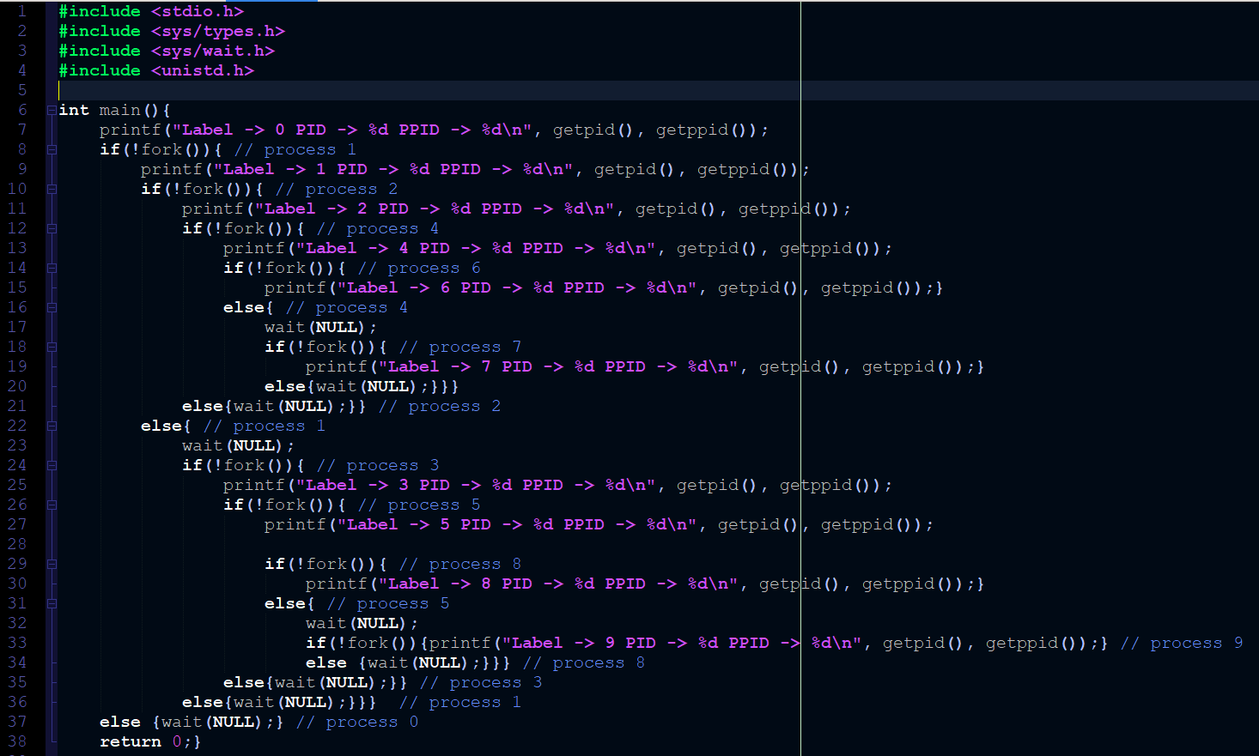  
   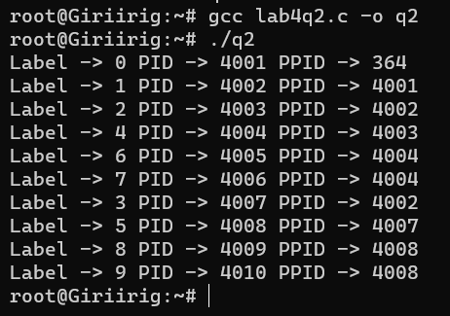**
2. **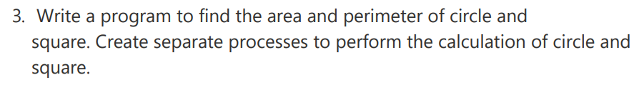  
   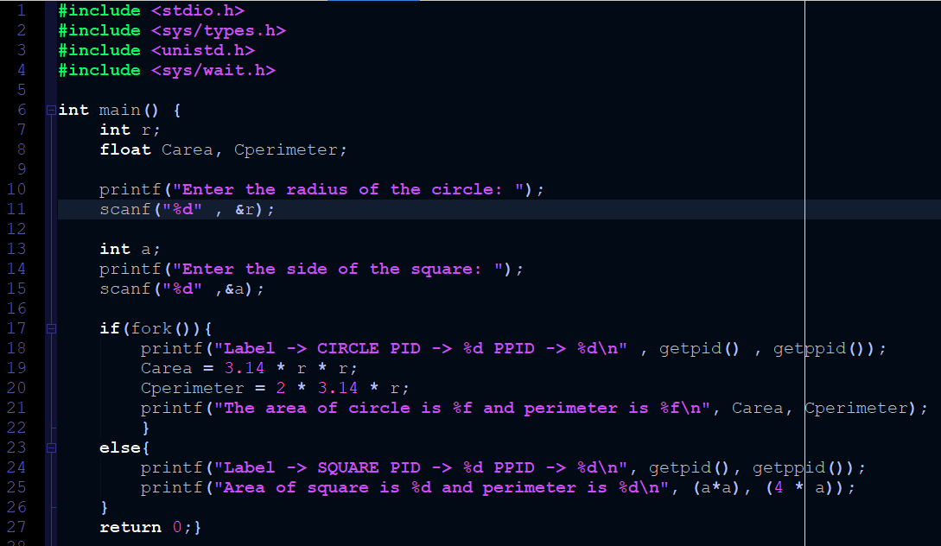  
   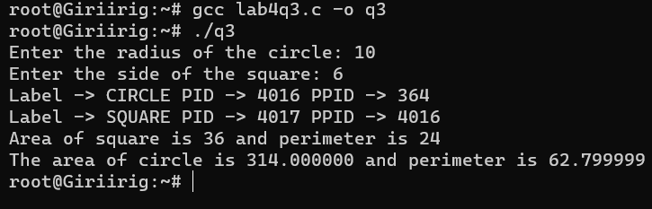**
3. **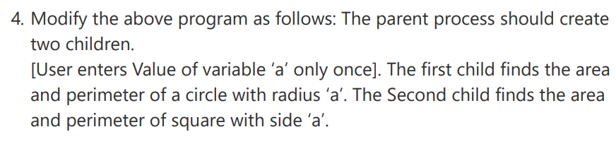  
     
     
   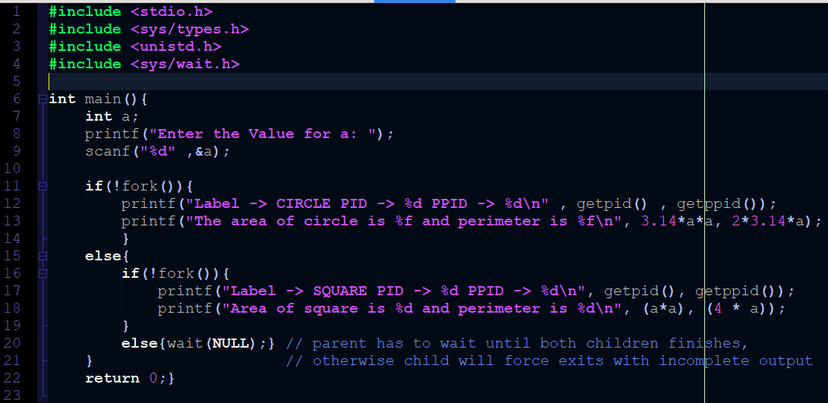  
   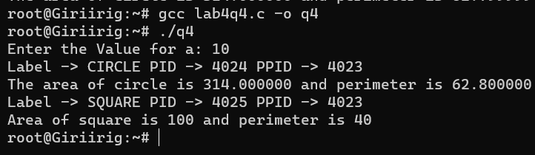**
4. **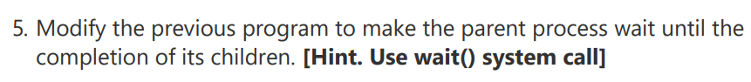  
   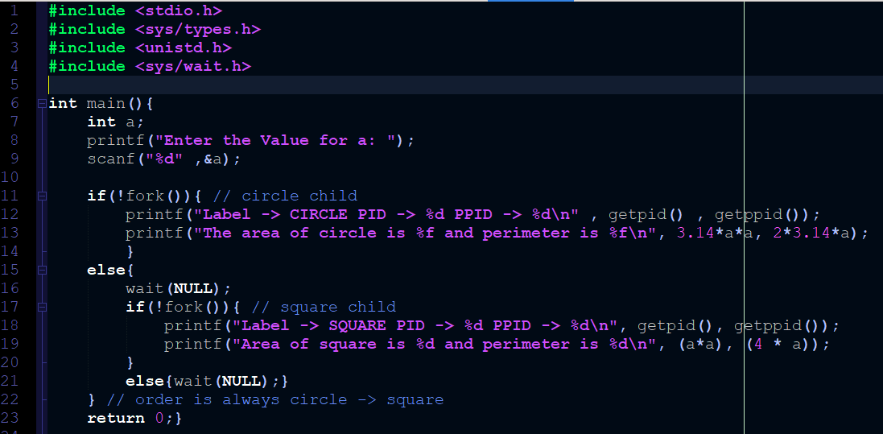  
     
   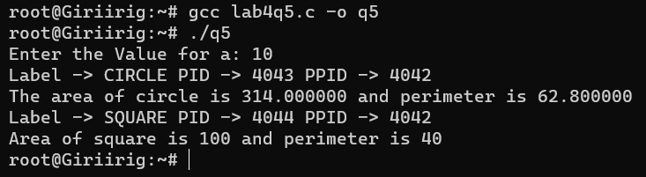**
5. **